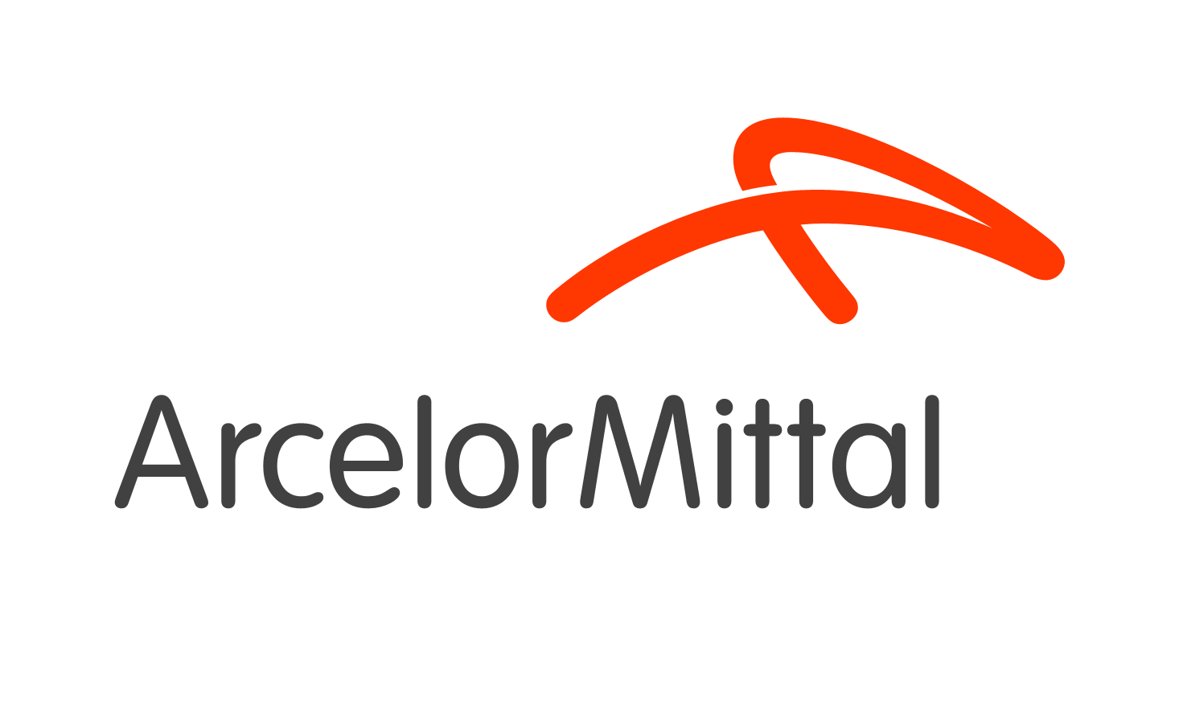

Annex to the Request for quotation adressed to Contractors executing services in ArcelorMittal Warszawa area.

We urge you to take knowledge of the safety requirements set by our company . The fulfillment of these requirements is a necessary condition for the commencement of work in our area . Please prepare also a set of documents confirming the fulfillment of the requirements - they must be presented ( we accept copies) during the General Safety Training carried out by our Department of Health & Safety for your employees.

In terms of the general principles of the work execution we require:
• designation of Contractor’s Health and Safety Coordinator, his personal data must be provided in a document transmitted to the AMW H&S Department
• to be in possession of a copy of valid medical certificate for employees performing work in AMW area
• compliance with regulations and rules of H&S

In terms of titles and qualifications we require :
• the list of persons with titles and qualifications who are designated to carry out the work in AMW area
• possession of a copy of professional qualifications , the certificate of completion of special training (for example, to perform the work at height ) and current health and safety training certificates by Company's employees who are performing work in AMW area
• a copy of the administrative decision authorizing the production of waste resulting from the provision of services
In terms of risks (including environmental risks ) we require:
• to submit in writing a card of an additional risk assessment (made before performing operations) to AMW’s representative who commissions the execution of a defined action .

In terms of clothing and protection measures we require:
• the use of branded workwear (name and / or logo of the company ) and use own personal protective equipment in accordance with applicable regulations.
In terms of equipment, machinery, specialized tools we require:
• list of safe, approved for use (where the law requires it) equipment, machinery , special tools.
• possibility to inspect relevant documentation confirming the current technical tests such as UDT , for the equipment used - where required

In terms of chemicals we require:
• to be in possess of Data Sheets of used chemicals and protections for people and the environment in case of an emergency , in accordance with the provisions of the cards ( absorbents, fire extinguishers, etc. )
In terms of the documentation we require :
• applicable safety instructions that will be used while working in the AMW area. The instructions must be available in AMW area during the work

In terms of environmental safety we require:
• protection against leakage of oils and lubricants
• restoration of order in working area after the work is completed
• protection against destruction of green areas around the place of work and in accessing zones.

In case of a breakdown generated by Contractor’s fault, he removes the effects of the breakdown or covers the costs of removing it.
The Contractor is obliged to inform the representative of the department in which he performs work about accidents and near misses occurred during the execution of works.
In case of non compliance to safety requirements the Company’s employee can be removed from the site of AMW.

